**16 BIT MULTIPLICATION**

**EXP NO: 11**

**AIM:** To write an assembly language program to implement 16-bit addition using 8085 processor.

**ALGORITHM:**

1. Load the first data in the HL pair.
2. Move content of HL pair to the stack pointer.
3. Load the second data in the HL pair and move it to DE.
4. Make H register as 00H and L register as 00H.
5. ADD HL pair and stack pointer.
6. Check for carrying if carry increment it by 1 else moves to the next step.
7. Then move E to A and perform OR operation with accumulator and register D.
8. If the value of the operation is zero, then store the value else go to step 3.

**PROGRAM:**

LHLD 2050:

SPHL

LHLD 2052

XCHG

LXI H, 0000H

LXI B, 0000H

DAD SP

JNC 2013

INX B

DCX D

MOV A, E

ORA D

JNZ 200E

SHLD 2054

MOV L, C

MOV H, B

SHLD 2056

HLT

INPUT:

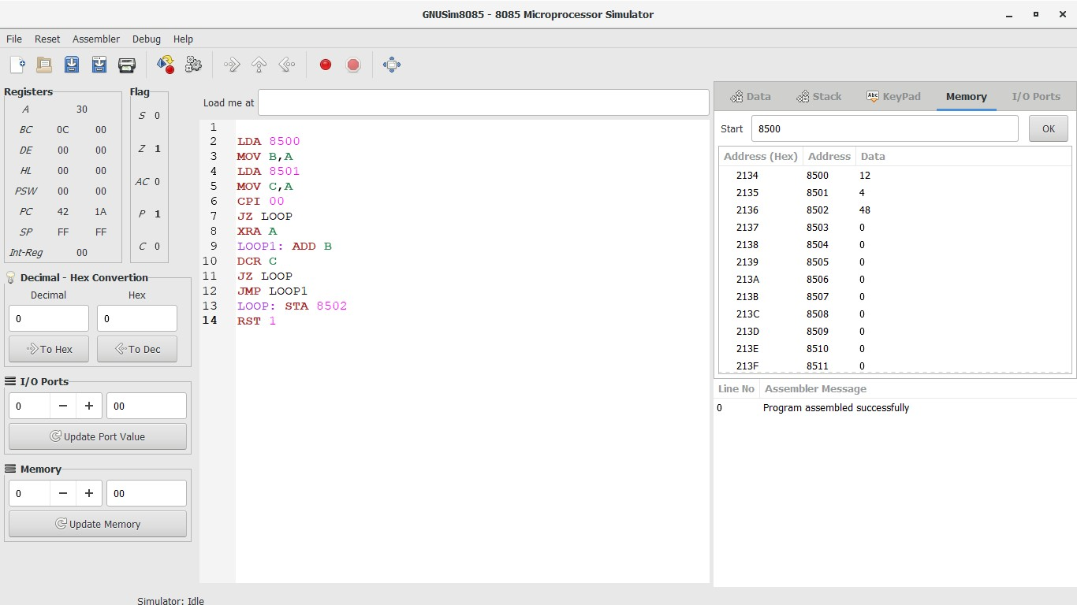

OUTPUT:



RESULT:

Thus the program was executed successfully using 8085 processor simulator.